Version <1.1>

10/6/18

Document Control

Approval

The Guidance Team and the Customer will approve this document.

Document Change Control

|  |  |
| --- | --- |
| Initial Release: | Version 1.0 |
| Current Release: | Version 1.1 |
| Indicator of Last Page in Document: | 5 |
| Date of Last Review: | 10/01/2018 |
| Date of Next Review: | 10/01/2018 |
| Target Date for Next Update: | 10/01/2018 |

Distribution List

This following list of people will receive a copy of this document every time a new version of this document becomes available:

Guidance Team Members:

Elsa Tai Ramirez

Jose Cabrera Maynez

Customer: Dr. Jaime Acosta

Mr. Christian Murga

Mr. Caesar Zapata

Software Team Members: Alan Caldelas

Oscar Galindo

Kevin Gonzalez

Isai Gonzalez

Julio De La Cruz

Change Summary

The following table details changes made between versions of this document

|  |  |  |  |
| --- | --- | --- | --- |
| Version | Date | Modifier | Description |
| 1.1 | 10/02/2018 | Alan Caldelas  Isai Gonzalez | Added the Purpose, Justification, Use case |
|  |  |  |  |
|  |  |  |  |

Table of Contents

Document Control ii

Approval ii

Document Change Control ii

Distribution List ii

Change Summary ii

1. Introduction 4

1.1. Purpose of the Feasibility Report 4

1.2. Justification for the Proposed System 4

1.3. Requirements Definition 4

1.4. Use Cases 4

2. Existing Solutions 4

3. Considerations 4

3.1. Consideration 1 4

3.2. Consideration 2 4

3.n Consideration n 4

4. Solutions 4

4.1. Solution 1 4

4.2. Solution 2 5

4.n. Solution n 5

5. Comparison of Solutions 5

6. Conclusions 5

7. References 5

# 1. Introduction

This outline is structured in sections. To display section breaks, headers and footers, from the View menu, point to Page Layout. To add information to a chapter, insert the information before a section break to ensure it flows onto the next page properly. Information inserted after a section break disrupts the header and footer layout scheme and results in incorrect pagination. For more information about section breaks, consult Microsoft Word’s online help. >>

## Purpose of the Feasibility Report

The purpose of this document is to assess the overall feasibility of the project. This report will discuss if it is possible to construct the system to meet the given requirements. The report will cover the topic of costs and licensees if any are required. This report will also cover the abilities of the developing team and maintainers to master the networking aspects of the system and the aspects of the complexity of the system including its support. Finally, the report will cover the different technologies that will be integrated into the system.

## Justification for the Proposed System

Security in the world is a crucial aspect that is always needed and always changing, especially in network systems. In a security perspective analyst need to be able to test the way systems communicate, which vary from protocols and backend software.

## Requirements Definition

<< Summary of RDD and additional information >>

## Use Cases

<< Should include Use Case Diagram (Level 1), Description of actors and Use Case.>>

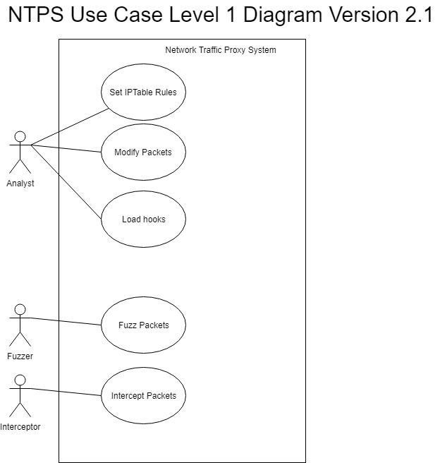

There are three external actors that will use the system: analysts, a fuzzer, and interceptor(s).

The analysts will be the main users of the system. They will interact with a lot of the system’s functions. They will also be able to interact with both the fuzzer and the interceptor(s) in certain ways to accomplish tasks. The analysts will be able to set IPTable rules to specify what their proxy will be able to receive and send. They will also be able to modify packets, that were intercepted or loaded in manually. Modifying packets would have steps and optional features, including fuzzing specific packets and its fields. Analysts will also be able to load hooks and use them on packets.

The other two actors will have more specific actions in this system as they are ultimately just needed for those actions. The interceptor will be intercepting packets for the system, and the fuzzer will be fuzzing packets when, as stated before, needed by the analyst.

# Existing Solutions

<< Introduce the section. Describe existing solutions, that satisfy some or all of the proposed system, including such things as functionalities satisfied, cost, and advantages and disadvantages.>>

# Considerations

<< Introduce the section. This section should present the different aspects to be considered to develop the proposed system, including external applications or services. Each consideration should provide a description of why it is needed and list the different options and their advantages/disadvantages. >>

## Consideration 1

## Consideration 2

## 3.n Consideration n

# Solutions

<< Introduce the section. Each solution should include options described in the previous section. Minimum of two solutions should be included in this section.>>

## Solution 1

<<Include requirements met and not met and resources needed.>>

## Solution 2

## 4.n. Solution n

# Comparison of Solutions

<< This section should discuss how each option measures up against any constraints set forth in the statement of requirements and how each compares with the others.

Include the following:

* Specific hardware and software requirements
* Time constraints
* Ease of use
* Staffing levels and training required
* User preference
* Security issues

A matrix that compares features is required. >>

# Conclusions

<< Summary and recommendations >>

# References

<< All information in the above text that comes from outside sources should be cited. All references that are cited should be enumerated below. >>